MS Word’s Track Changes
By Linda Q. Thede

Using track changes can be VERY confusing when there has been a lot of editing. You may be very familiar with this feature, but if not, this information is included for your convenience.

Seeing the document with the suggested changes and no other text.

When you open the document, you may see red edits all over and find it hard to distinguish between what is the “real” document, and what has been suggested as needed as editing. To see the document as the editor intended it to be read, start by clicking on the Review tab.

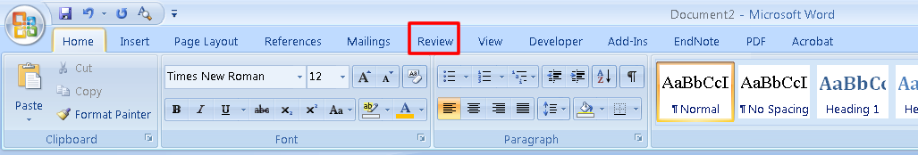
Figure 1 - Selecting Review Ribbon

On the review tab, in the tracking tab, click on the arrow in the right corner of “Final Showing Markup (circled in blue).

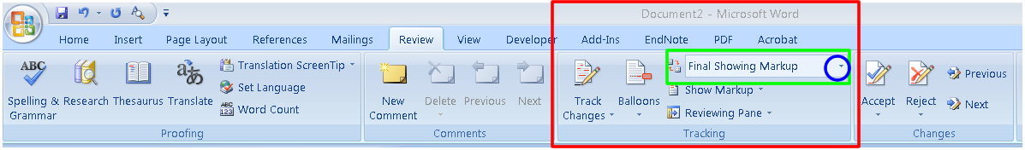
Figure 2 -To change view

And select “Final.”
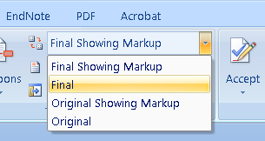
Figure 3 - seeing the manuscript as the last editor intended

To see the comments as well as other suggested edits:

To see the comments, with the review tab open click on Reviewing Panel as seen in figure 4.

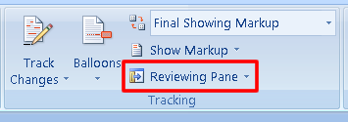
Figure 4 - Making comments visible

Make selection for where on the screen to place the review panel from the drop down panel as seen in Figure 5.

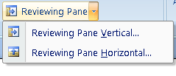
Figure 5 - selecting whether to see review pane on side or bottom of screen

Comments

A comment can be easily inserted using the New Comment Icon on the review tab as seen in figure 6. It can also be easily deleted by selecting the comment and clicking on “Delete” (grayed out in figure 6. Or, with the insertion point on the comment in the review pane, right click and select “Delete comment.”

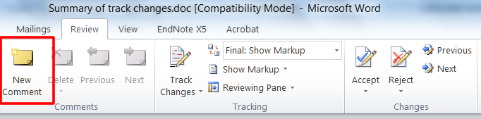

Figure 6 - Entering a comment

Accepting or rejecting changes.

To accept or reject a change click on either “Accept” or “Reject” on the Changes Group in the Review tab (figure 7).

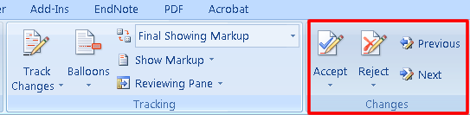

Figure 7 - starting to accept or reject changes

Next, click on the arrow under accept or reject to see the choices as seen on figure 8.

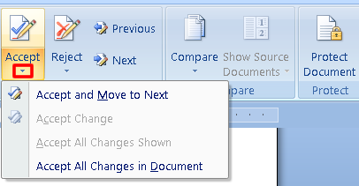
Figure 8 - Accept or Reject Changes

Shown in figure 8 is the drop down menu for Accept which is similar to the one for Reject.

BEFORE submitting a manuscript to the editorial manager, be sure to accept or reject all the changes as well as delete comments!!!

For more information on the power of this feature see: Thede, L. Q. (2009). Track changes: using Microsoft Word's editing tool. CIN: Computers, Informatics Nursing, 27(1), 16-17.

All rights reserved © 2012 Linda Q. Thede

